Union College Spring 2016
Astronomy 50 Lab: Diameter of the Earth:

Aristotle knew that the Earth was spherical and not flat. There were several observations that Aristotle used to argue this fact. One such observation was that the position of the North Pole star above the horizon changes as one moves around the Earth. In this lab, you will use this effect to not only to prove that the Earth is spherical, but how large a sphere it is. The principle here is that because the surface of the Earth is curved, as you view a celestial object at different positions on the Earth the direction of that object relative to the ground will change. Consider Figure 1 below, where two observers are located at different places on the Earth and view the North Pole star. The angle between the object and the horizon is known as the object’s “elevation angle.”
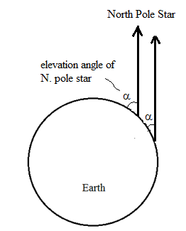
Figure 1: Elevation angle of the North Pole star, α, at two locations on the Earth.

The curve of the Earth's surface causes the orientation of the ground to vary and so the direction of the North Pole star relative to the ground must vary as well. This is an easily measurable effect and depends solely on the sharpness of the curvature of the Earth's surface, which is related to the radius, or diameter, of the Earth. This effect, therefore, can be used to measure the size of the Earth. This was realized by an Egyptian astronomer named Eratosthenes in about 200 BC, who used the direction of the Sun relative to the ground at two locations to obtain a measure of the diameter of the Earth.
We need, though, to make this measurements in two locations. For this lab, we will coordinate with some collaborators at the Sayab Planetarium in Playa del Carmen, Mexico.
Let’s first discuss how the elevation angles of the North Pole star at different locations relates to the diameter of the Earth, and then we’ll discuss how to obtain the data. Imagine, for now, that the two locations are due North-South of each other. (Our two locations are NOT due North-South of each other. We will explain later how to account for that.) Then, the two locations and the North Pole star all lie in the same plane and therefore fit on a page, as in Figure 2 below. The angles α1 and α2 are the elevation angles of the North Pole star Sun and the angle θ is the angle between the two locations as seen from the center of the Earth.
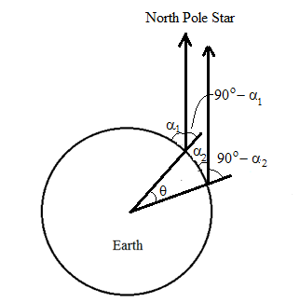
Figure 2: The angular North-South separation of two locations on the Earth, θ, and the elevation angles, α₁ and α₂, of the North Pole star at the two locations.

Now note that the separation angle, θ, between the two locations is a fraction θ / 360o of the way around the Earth. Likewise, the physical distance between the two locations is the same fraction of the circumference of the Earth. If we call the physical distance s and the circumference C, then
θ / 360o = s / C. (1)
Since the circumference of the Earth is πD, where D is the diameter of the Earth, then we can rewrite Equation (1) as an expression of the Earth’s diameter as
D = (s/ π) (360o / θ). (2)
Since we will know s (the distance between the two locations), we need only to figure out how θ relates to the elevation angles, α1 and α2, to see how we can get the diameter of the Earth.
To see how θ relates to α1 and α2, consider the other two angles labeled in Figure 2. Since the ground makes a 90o angle with the vertical at each location, the angle 90o − α is the angle between the line pointing to the North Pole star and the extension of the line pointing to the center of the Earth, as indicated. And, since the North Pole star is, essentially, infinitely far away, the lines pointing to the North Pole star from two locations on Earth are parallel. Now, try the following exercise (taken from “Stephen Hawkin’s Universe Teacher’s Guide”).
1. On a piece of lined paper, draw any two intersecting lines, as shown below.
2. With a protractor, measure the angle each line makes with one of the parallel printed lines (angles ‘a’ and ‘b’ in the diagram). The printed lines represent the parallel lines pointing to a celestial object, like the Sun.
3. Subtract one angle from the other.
4. Measure the angle between the two lines where they intersect (angle ‘c’ in figure).
5. Compare angle c with the difference between a and b.
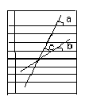
Figure 3: Relation of the angle between two lines and the angles they make with a set of parallel lines.

Compare the situation of the lines and angles drawn on the lined paper and that in Figure 2 above. The parallel lines on the paper are like the rays pointing to the North Pole star and the diagonal lines are like the lines going from the center of the Earth to each observing location. From this analogy, can you see that in Figure 2, we should have
θ = (90ο − α1) − (90ο − α2)?
With just a little algebra, we get that
θ = α2 − α1. (3)

[Here’s a geometrical proof of this equation, for those of you not satisfied. First, add to Figure 2 a line from the center of the Earth to the North Pole star, as shown in Figure 3, below. The lines pointing to the North Pole star from each location and from the center of the Earth are all essentially parallel, so by the geometrical rule of alternate interior angles, the angles 90o-α1 and 90o-α2 are equal to the angles between this new line and the lines from the center of the Earth to each city, as shown.
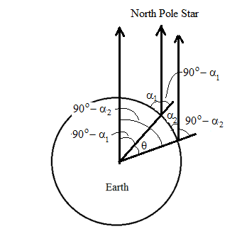
Figure 4: Relation between θ and α₁ and α₂.
Then, by examining the angles at the center of the Earth, we can see that
θ = (90o − α1) − (90o − α2),
and hence θ = α2 − α1.]
In this lab, we'll measure α1 and α2 directly to get θ via Equation (3) and then by determining s you will use Equation (2) to get the Earth's diameter.

Measuring the elevation angle of the North Pole star.
A good and easy method for measuring the elevation angle of the North Pole star involves a easily made device known as a “quadrant,” which is depicted in Figure 5. To make this device, 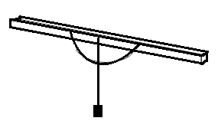
Figure 5: Depiction of a quadrant
thumbtack a protractor to the side of a stick so that its flat edge is parallel with the edge of the stick. Attach some string to the same thumbtack and tie a weight onto the other end of the string. The string with the weight, then, points straight down from the center of the protractor. Now place one end of the stick to your cheek, just under your eye and sight the North Pole Star along the length of the stick, so that the stick points at the star. While holding the stick in this position, have a friend read what angle the string crosses on the protractor. However, this number alone is not the correct answer. You also need to "calibrate" your instrument. When the stick is horizontal (pointing to the horizon, for example), the elevation angle should be 0º. You should find, though, that it does not read 0º when it is horizontal. What does it read? This is your zero-point. Now, when you point to the North Star, you need to compare your reading with the zero-point reading to infer the angle of elevation.
Construct your quadrant and then, on a clear night, take it to some place where you have a clear view of the Northern horizon.

Finding the North Pole star:
In the evening sky in early April, you should be able to find the Big Dipper fairly high in the sky, and upside down, as shown in Figure 6. The Big Dipper has seven bright stars, three of which make a handle and then four to compose the pan (the part used to “dip” into water). If you think
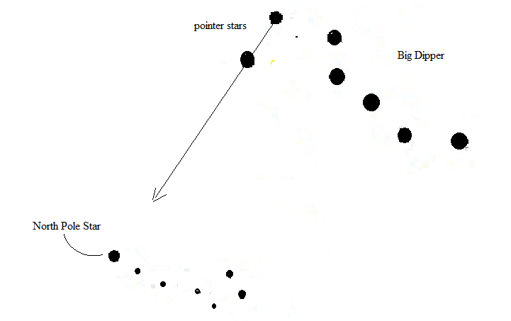
Figure 6: In late April, the Big Dipper is upside down and high in the sky and so easy to find. The last two stars in the big dipper point the direction to the North Pole star, which is the first star in the Little Dipper.
of the star at the end of the handle of the dipper as star number 1, then take the line between the last two stars in the pan, from star 6 to 7, and continue until you run into another moderately bright star. This moderately bright star is the North Pole star. (The last two stars in the big dipper are also known as the “pointer stars” because they guide us to the North Pole star, which was historically an important star to find as this is useful for celestial navigation.) You can confirm that it is the North Pole star if you can see that it is also the first star in the little dipper. However, stars 2-5 of the little dipper are quite faint and not see easy to see if there are city lights or a full moon lighting the sky.
Using your quadrant, measure the elevation angle of the North Pole star. This is the value of α₁ in the equations above. Our collaborators in Mexico will tell us what the elevation angle they measure, which you should use as the value of α₂.

Determining the distance s:
Finally, now, we discuss how to determine the value of s. Remember that the s in Equations (1) and (2) was the distance between two locations that were due North-South of each other, and the locations we are using also have an East-West component to their distance. Consider the location on the Earth that is due South of Schenectady and due East of Playa del Carmen, Mexico. In Figure 7, which shows a Google Map of the North America, The location of Playa del Carmen is indicated by a pin and Schenectady is indicated with a red “S”. North-South and East-West lines are added. Consider, now, what the elevation angle of the North Pole star would be from the place where these line cross – it will be the same as that from Playa del Carmen, since all that matters is how far above the northern horizon the North Pole star is. Therefore, we can imagine that the elevation angle measured by our collaborators in Playa del Carmen was actually measured at the location where the lines cross and, therefore, for the value of the distance s we can use the length of just the North-South line. Note the distance scale indicator in the lower right corner of Figure 7. Use this scale and a ruler to measure the distance s in our observation. (Note: we should not use a globe or make use of the latitudes to infer this distance, since either of these methods implicitly assumes prior knowledge of the Earth's diameter.)

Additional questions to consider discussing in your report:
1. Exploration of and travel across the oceans long before the invention of GPS required repeated determination of one’s location on the Earth. Consider and discuss how measurement of the elevation angle of the North Pole star provides one part of the information of one’s location.
2. How do observations like this prove that the Earth is not flat? Do you believe that elementary school stories that the Christopher Columbus’ sailors believed that the Earth was flat and that they feared they were going to fall off the edge of the Earth.

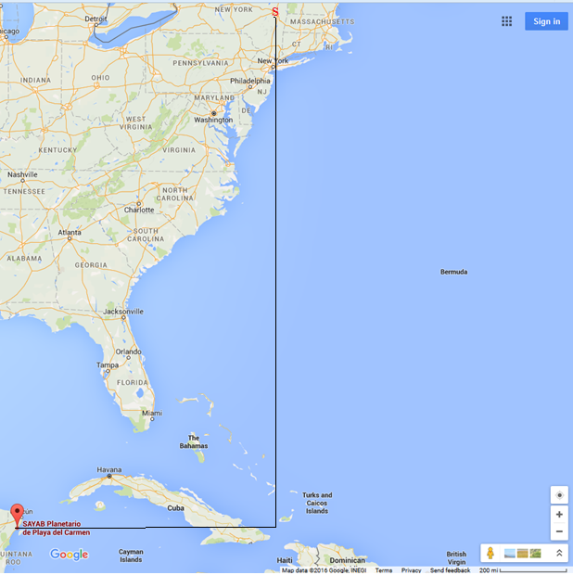Figure 7: Map containing both Schenectady, NY and Playa del Carmen, Mexico, and the North-South line running through Schenectady and the East-West line through Playa del Carmen (taken from Google Maps).

